**UOFL WEBSITE**

**Inception Phase Specification:**

**Website Assessment**

**Version 3.0**

**Revision History**

|  |  |  |  |
| --- | --- | --- | --- |
| **Date** | **Version** | **Description** | **Author** |
| 18 February 2023 | 1.0 | Iteration 1 | Team Ace |
| 4 March 2023 | 2.0 | Iteration 2 | Team Ace |
| 26 March 2023 | 3.0 | Inception Phase Specification | Team Ace |
|  |  |  |  |

TABLE OF CONTENTS

1. Introduction 7
   1. References 7

2. Positioning 7-8

2.1 Problem Statment 7

2.2 Product Position Statement 8

3. Stakeholder and User Descriptions 8-12

3.1 Stakeholder Summary 9

3.2 User Summary 9

3.3 User Environment 10

3.4 Summary of Key Stakeholder or User Needs 11

3.5 Alternatives and Competition 12

4. Product Overview 12-13

4.1 Product Perspective 12

4.2 Assumptions and Dependencies 13

5. Product Features 14

6. Other Product Requirements 14-29

7. Initial Architecture Considerations 27-28

7.1 Design Viewpoint 29

7.2 Realistic Viewpoint 32

8. Risk Analysis 33

9. Team Charter 34-35

10. Gantt Chart 35

11. Inception Phase Prototype 35-42

12. Appendix A: Feasibility Analysis 42

13. NPV Analysis 43-44

**System Request – UofL Basketball Team Website and Database**

The UofL basketball team needs a central hub for all the team's data. They also need a website where coaches can access this data and be able to implement the data for practice and game plans. The website will allow coaches to be able to watch game films from the past game and the last 10 games and will provide accurate details of each game and play. The website will also serve as a central place for managers, administrators, and nutritionists to be able to upload their data, or be able to look at past data entered.

**Business Needs:** The why behind the whole project.

* Exclusive database/website for basketball team
* Increase efficiency of tracking all data regarding the team and players
* Increase Security of important data
* Data Visualization: Make hard data easy to understand for coaches/faculty

**Business Requirements:** What our system will be capable of

* Online Website: Act as a home for all staff. Will help lead members of staff to their desired points of interest.
* Database: Managers and other Staff can input data for the team. Will store all the team data.
* Firewalls/Multi Authentication: Allow for more security of Player info and Team Data.
* Payment system

**Business Value:** The benefits of integrating the system

* Coaches will have access to useful player information and analytics which they can use to adjust training and other factors to improve performance
* Admins and Managers will be able to upload and retrieve data from a central location
* The ability to have sensitive information encrypted and secure

**Special Issues / Constraints:** Issues related to the implementation of the system and decisions

* Need to constantly update data such as player statistics
* Cybersecurity of website
* Deadline: April 28,2023

**Project Sponsor:** The person who initiates the project and serves as point of contact:

* Dr. Zara Hatami, CIS Professor at UofL, [zara.hatami@lousiville.edu](mailto:zara.hatami@lousiville.edu)

**Vision (Small Project)**

**Introduction**

**The purpose of this document is to collect, analyze, and define high-level needs and features of the Louisville Basketball Team Website. It focuses on the capabilities needed by the stakeholders and the target users, and why these needs exist. The details of how the Louisville Basketball Team Website fulfills these needs are detailed in the use-case and supplementary specifications.**

**1.1**

**References**

**WordPress Official Website:**

[**https://wordpress.com/**](https://wordpress.com/)

**2.**  **Positioning**

**2.1**  **Problem Statement**

|  |  |
| --- | --- |
| **The problem of** | **-No centralized database**  **-No way to filter and easily utilize data**  **-Difficulty uploading data** |
| **affects** | **-Justin Perez**  **-UofL coaching staff**  **-UofL basketball players** |
| **the impact of which is** | **-Less useful data**  **-More time spent uploading data and making it useful to coaching staff**  **-Data that does not benefit the team as much as it could** |
| **a successful solution would be** | **-A centralized, easy to use database**  **-A website**  **-A secure way to get into the data base to ensure security** |

**2.2**  **Product Position Statement**

|  |  |
| --- | --- |
| **For** | ***Louisville Basketball Team*** |
| **Who** | ***Need a centralized website and database to keep track of all the player data.*** |
| **The (product name)** | ***Is a website*** |
| **That** | ***Stores and showcases data all in one place*** |
| **Unlike** | ***The current system which is complicated and stores the data in many different places*** |
| **Our product** | ***Is simple, secure, easy to use and keeps all the data in one place for analytics and ease of access*** |

**3.**  **Stakeholder and User Descriptions**

**Currently, the University of Louisville Men’s basketball team does not have a website of their own or a centralized database to store all the player data whether it be from games or nutrition data. The way it’s currently handled, data is gathered and entered into many different spreadsheets, is cleaned and it’s then shared with the parties that need it, such as coaches or nutritionists. Many different people work on the spreadsheets and it’s hard to keep track of them, leading sometimes to data integrity issues. Moreover, analytics and visualization of the data is pretty much non-existent. Our system aims to provide a website with a centralized database that is both secure and easy to access, so that all of data is in a single place, we will also plan to implement data analytics and visualization to make it easier to interpret the data.**

**3.1**  **Stakeholder Summary**

|  |  |  |
| --- | --- | --- |
| **Name** | **Description** | **Responsibilities** |
| ***Louisville Men’s Basketball Team*** | ***University of Louisville Men’s Basketball Team*** | ***The primary responsibility of the Louisville Men’s Basketball Team is to be well trained in the best shape they can be so that they can perform the best they can and win games. Within the team, there are coaches, nutritionists and other entities that make this possible. Their role in the system will be to update the player/game data, interpret such data, and make the necessary changes to training and nutrition.*** |

**3.2**  **User Summary**

|  |  |  |  |
| --- | --- | --- | --- |
| **Name** | **Description** | **Responsibilities** | **Stakeholder** |
| ***Coaches***                          ***-Nutritionists*** | ***They will analyze, interpret data and then make the necessary changes to training***    ***They will analyze, interpret data and then make the necessary changes to training*** | ***- Uses website to find player data.***  ***- Updates data accordingly***  ***- Makes necessary changes to training***            ***- Uses website to find player data.***  ***- Updates data accordingly***  ***- Makes necessary changes to nutrition*** | ***Justin Perez- Director of Men’s Basketball Administration*** |

**3.3**  **User Environment**

***As it currently stands, users interact with the current system through multiple different spreadsheets, which is both tedious and time-consuming and could lead to issues with data integrity. With our new system, we aim to create an environment where all the data can be found in one place, making it simple, secure and hassle-free.***

**3.4**  **Summary of Key Stakeholder or User Needs**

|  |  |  |  |  |  |
| --- | --- | --- | --- | --- | --- |
| **Need** | **Priority** | **Concerns** | **Current Solution** | **Proposed Solutions** | |
| **-Centralized Database** | **High** | **Without data being centralized, it makes to process of adding, updating, and analyzing player data a lot more complicated.** | **Currently, there is no real solution as there is no centralized database** | | **Implementing a centralized database that can be accessed through the website.** |
| **-Secure Data** | **High** | **Some of the data that is being used is of very sensitive nature and the current system is not very secure.** | **Currently there is not much security for data, some of the spreadsheets are shared over unencrypted emails which could be easily intercepted by hackers.** | | **Our website will only be accessible internally and therefore will have to be logged into using a vpn, we will also implement 2-factor authentication to further secure the data, especially user login.** |
| **-Ease of access to Data** | **Medium** | **Coaches and nutritionists don’t have the time to be searching through multiple spreadsheets** | **There is no current solution for this, as accessing or modifying data is currently a very complicated process.** | | **A centralized database with filters and built in analytics will solve this.** |

**3.5**  **Alternatives and Competition**

***The alternative to our proposed solution would be to keep using the current system, which means that data will continue to be unsecured, shared using multiple spreadsheets and tedious to access and modify.***

**4.**

**Product Overview**

**4.1**  **Product Perspective**

***Our product will be self-contained. Coaches, Nutritionists and Admins will be the direct users of our product. We may use the legacy system(spreadsheets) to transfer all of the current data to our new system, but once this is done it won’t be used anymore.***

**4.2**  **Assumptions and Dependencies**

***This product assumes the availability of the CMS WordPress and the ability of the Louisville Men’s Basketball Team to pay for any costs incurred for the project, including but not limited to initial costs and recurring costs such as the maintenance of the website and WordPress fees. We also assume the technical literacy of admins and other parties that will be uploading and updating information on the website’s database.***

**5.**  **Product Features**

**-WordPress:**

* **Open Source.**
* **Low Maintenance fee. ($25/month)**
* **It can also host the website.**
* **Content management tools make it easy to edit content.**
* **Plenty of plug ins make the implementation of features like login as well as multiple users and access levels a lot simpler.**
* **Technical Support is among the highest rated**

**-Website:**

* **Navigation bar: Home, Previous Game, Events, Players, Help.**
* **Log in**
* **Different user types and access levels**
* **Built-in filtering and analytics**
* **Integrated Database**
* **Internal website**

**6.**  **Other Product Requirements**

**Our product will require the development of a website and a perfect integration between it, our chosen CMS tool, WordPress, and our Database. Our product will need to be scalable given that new and updated data will be constantly added. It will need to be intuitive and easy to use from the front end for Coaches and Nutritionists who will be reviewing the data and analyzing it, while also being easy to use from the back end for the admins and the people uploading, modifying and cleaning the data.**

3. Process Models

3.1. AS-IS Process Model

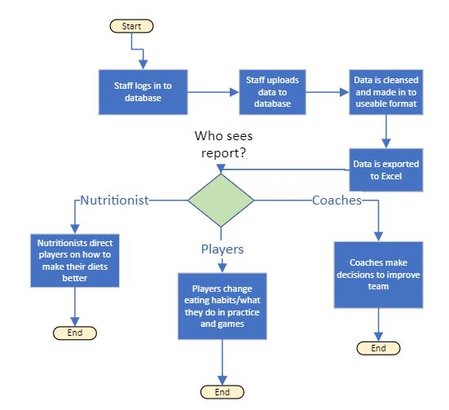

3.2 To-Be Process Model

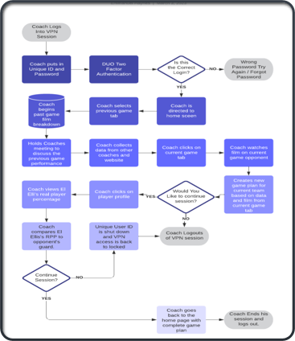

**System Requirement**

**Functional Requirements**

LogIn Page Requirements

ID: SR001 - The login page will allow for certain users to login into the website

ID: SR002 - The login page will allow for two factor authentication for all users

ID: SR003 - The login page will allow for VPN’s to be established on users devices

ID: SR004 - The login page will allow users to login anywhere at any time

Home Page Requiremen**ts**

ID: SR005-The home page will allow all information to be centralized / edited

ID: SR006 - The home page will allow for information to be stored

ID: SR007-The home page will allow data to be posted from managers…etc

ID: SR008-The home page will allow different paths to different functions based off needs

ID: SR009-The home page will allow data to be deleted if given permission

Previous Game Requirements

ID: SR010- The previous game page will allow previous game data to be created

ID SR011 - The previous game page will allow previous game film to be uploaded

ID SR012 - The previous game page will allow previous game data to be edited

ID SR013 - The previous game page will allow previous game data to be deleted

Event Page Requirements

ID SR014 - The event page will allow events to be created

ID SR015 - The event page will allow events to be edited

ID SR016 - The event page will allow events to be deleted

ID SR017 - The event page will allow event pictures to be uploaded

Player Page Requirements

ID SR018 - The player page will allow player profile to be edited

ID SR019 - The player page will allow player profiles to be created

ID SR020 - The player page will allow player information to be downloaded

ID SR021- The player page will allow for two factor authentication when accessing player information

ID SR022 - The player page will allow for player profiles to be deleted

Help Page Requirement

ID SR023 - The help page will allow help articles to be created

ID SR024 - The help page will allow help articles to be edited

ID SR025 - The help page will allow help articles to be deleted

ID SR026 - The help page will allow for directions on how to use certain features of the website

ID SR027 - The help page will allow for users to be redirected to a dedicated help desk team

**Non-Functional Requirements**

Performance Requirements

ID SR 028 - The website will load quickly

ID SR 029 - The website will run with no errors

ID SR 030- The website will be updated daily

Security Requirements

ID SR 031- The website will have an active firewall protecting the internals of the website

ID SR 032 - The website will function on a two factor authentication login system

ID SR 033 - The content management system will authenticate the web administrator

ID SR 034- The content management system will alert the web admins if there is a data breach and the lock website.

Capacity Requirements

ID SR035- content management system will be able to process and filter data efficiency

ID SR036 - the content management system will be able to hold large amounts of data

Availability Requirements

ID SR037- The website will be accessible at all times

ID SR038 - The website will allow display multiple tabs

ID SR039 - The website will adhere to W3C web accessibility standards

ID SR040 - The website will compatible with most devices

ID SR041 - The website will be compatible with most web browsers

ID SR042 - Website users will be able to sign up for the email newsletter

ID SR043 - Admins and other authorized users will be able to send out an email newsletter

Use Cases

**Use Case 1**: Edit Website Information

Primary Actors: Administrators

Description : Website information can be edited if needed

Risk Level: Low

**Use Case 2:** Nutritionist updates Player nutrition plan

Primary Actors: Nutritionist

Description: Nutritionist can upload nutrition plan for player to the website

Risk Level: Medium

**Use Case 3**: Information needs to be deleted off website

Primary Actor: Administrators

Description: Wrong information needs to be removed off the website

Risk Level: High

**Use Case 4**: Create New Player Profile

Primary Actor: Administrator

Description: New player profile can be uploaded

Risk Level: High

**Use Case 5**: Delete player profile

Primary Actor: Administrator

Description: Player profile needs to be deleted

Risk Level: High

**Use Case 6**: Edit player profile

Primary Actor: Administrator

Description: Player profile needs to be edited

Risk Level: High

**Use Case 7**: Player Wants To Review Film

Primary Actor: Player

Description: Player wants to review previous game film

Risk Level: Medium

**Use Case 8**: Coach Wants To Review Film

Primary Actor: Coach

Description: Coach wants to review previous game film

Risk Level: Medium

**Use Case 9**: Admin Needs To Login From Home Device

Primary Actor: Administrator

Description: Administrator needs to login from home device

Risk Level: High

**Use Case 10**: Player Wants To Login From Mobile Device

Primary Actor: Player

Description: Player wants to login from mobile device

Risk Level: High

**Use Case 11**: Coach Wants To Login From Home Device

Primary Actor: Coach

Description: Coach wants to login from home device to watch film

Risk Level: High

**Use Case 12**: Create New Post in Feed

Primary Actor: Administrator

Description: Practice update needs to be posted for players to view.

Risk Level: High

**Use Case 13**: Edit Post in Feed

Primary Actor: Administrator

Description: Post in feed needs to be edited.

Risk Level: High

**Use Case 14**: Update Strength Statistics

Primary Actor: Strength and Conditioning Coach

Description: Player needs strength statistics updated.

Risk Level: High

**Use Case 15**: Practice Information Being Uploaded

Primary Actors: Managers

Description: Managers can upload practice information to the website

Risk Level: Medium

**Use Case 16**: Create New Event

Primary Actor: Administrator

Description: An event needs to be created.

Risk Level: Medium

**Use Case 17**: Edit Event

Primary Actor: Administrator

Description: An event needs to be edited.

Risk Level: Medium

**Use Case 18**: Delete Event

Primary Actor: Administrator

Description: An event needs to be deleted.

Risk Level: Medium

**Use Case 19**: Upload Event Pictures

Primary Actor: Administrator

Description: Event pictures need to be uploaded for team viewing.

Risk Level: Medium

**Use Case 20**: Administrator Adds Previous Game Film

Primary Actor: Administrator

Description: Administrator adds previous game film to previous game tab

Risk Level: Medium

**Use Case 21**: Head Coach Watches Previous Game Film

Primary Actor: Head Coach

Description: Head Coach watches previous game film on the plane heading to the next game in order to prepare for it.

Risk Level: High

**Use Case 22:** Download Player Information

Primary Actor: Player

Description: Download a player’s information and statistics.

Risk Level: High

**Use Case 23**: Create Help Page Article

Primary Actor: Administrator

Description: New information needs to be posted to the Help Page.

Risk Level: Medium

**Use Case 24**: Edit Help Page Article

Primary Actor: Administrator

Description: Information on the Help Page needs to be edited.

Risk Level: Medium

**Use Case 25**: Delete Help Page Article

Primary Actor: Administrator

Description: Information on the Help Page needs to be deleted.

Risk Level: Medium

**Use Case 26**: Speak to a Help Desk Representative

Primary Actor: Player

Description: A player needs to speak to a help desk representative.

Risk Level: Low

**Use Case 27**: Send Email Newsletter

Primary Actor: Administrator

Description: A newsletter can be sent to all distribution list subscribers.

Risk Level: High

**Use Case 28**: Admin Wants To Edit Previous Game Data

Primary Actor:A dmin

Description: Admin wants to edits previous game data

Risk Level: Medium

**Use Case 29**: Nutrionist Has New Player Diet Recommendation

Primary Actor: Nutrionists

Description: Nutrionists adds new diet change recommendation

Risk Level: High

**Use Case 30**: Admin Needs To Delete Previous Physical Data

Primary Actor:Admin

Description:Admin deletes previous physical data because of error

Risk Level:High

**Use Case 31**: Coach Wants To View Players PPG from Last 5 Games

Primary Actor: Coach

Description: Coach needs to view El Ellis’s PPG from last five games

Risk Level: Medium

**Use Case 32**: Coach Wants To View Shot Spread and Shot Selection

Primary Actor: Coach

Description: Coach wants to view team shot selection spread from last game

Risk Level: High

**Use Case 33:**  Coach Wants To View Top Performer From Last Game

Primary Actor:Coach

Description: Coach wants to go through team stats and identify the top performer from the previous game

Risk Level: Medium

**Use Case 34**: Coach Wants To Identify Players Free Throw Percentage From Last 5 Games

Primary Actor: Coach

Description: Coach wants to identify players free throw percentage from last 5 games

Risk Level: Medium

**Use Case 35**: Coach Wants To View Opponents Top Performer for Current Game

Primary Actor:Coaching Staff

Description: Coaching staff wants to view opponents top performer for current game in order to create game plan for the current game.

Risk Level:Medium

**Use Case 36**: Admin Adds Current Oppenents Team Information To Database

Primary Actor:Admin

Description:Admin adds current opponents team information to the database to be used for review

Risk Level: High

**Use Case 37**: Admin Uploads Medical Data To Player Profiles

Primary Actor:Admin

Description:Admin uploads medical data to player profile

Risk Level: Medium

**Use Case 38:** Upload Practice footage

Primary Actor: Admin

Description: Admin uploads practice footage to be used as a tool for players and coaches.

Risk Level: High

**Use Case 39:** Edit Practice Footage

Primary Actor: Admin

Description: Admin is able to edit footage into segments at coaches discretion.

Risk Level: Medium

**Use Case 40:** Delete Practice footage

Primary Actor: Admin

Description: Admin is able to delete old footage that is no longer needed.

Risk Level: Low

6. TRACE MATRIX

[Link to Google Sheet](https://docs.google.com/spreadsheets/d/1uHtFi1Ucwlmen7pZhSKUk3nH8lbFtjVm/edit?usp=sharing&ouid=115802497020609023982&rtpof=true&sd=true)

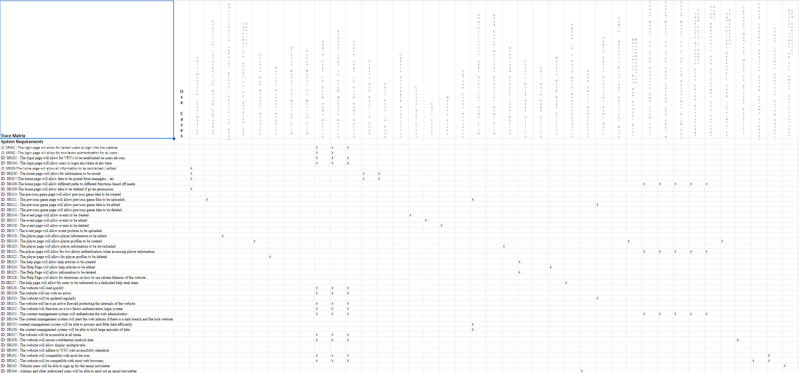

7. Initial Architecture Considerations

7.1 Design Viewpoint

The design architecture is set in place to help ensure that the needs and goals of the UofL men’s basketball team are met through our content management system. We would like to ensure that the content management system is both functional, secure, and usable. The design architecture will help set in place the foundation of our CMS system to make sure that our client will agree with the layout , so that costly redesigns are avoided. The second design is the realistic view which will highlight the content management system and cloud system that will be implemented to meet the requirements of our client. WordPress is a content management system that will serve as the centralized database that is both easy to use and will ensure security. It will also include plenty of plug-ins including cloud service system. These elements will all work together to build a robust system design for the website.

Design View

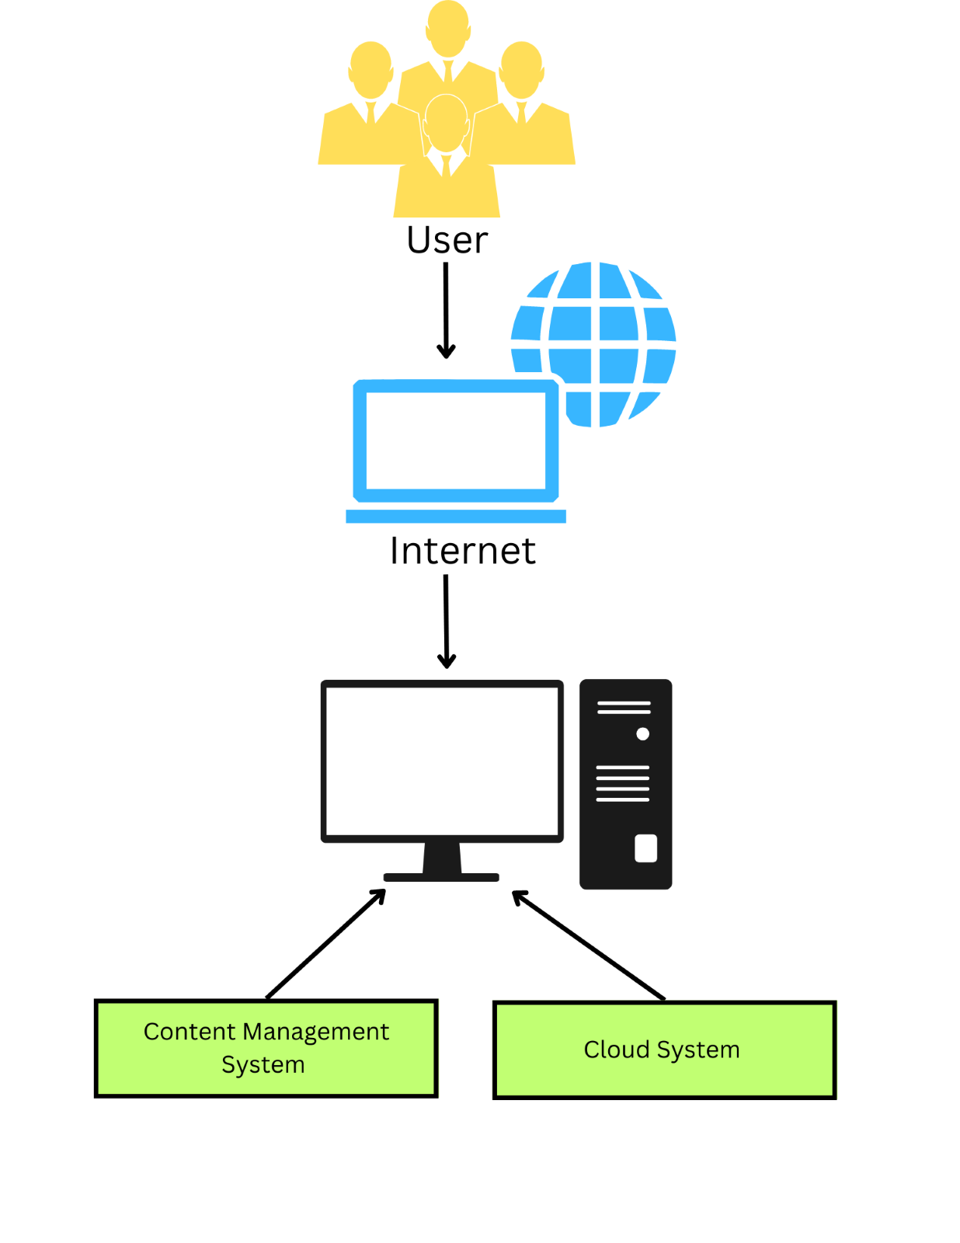

7.2 Realistic Viewpoint

Realistic View

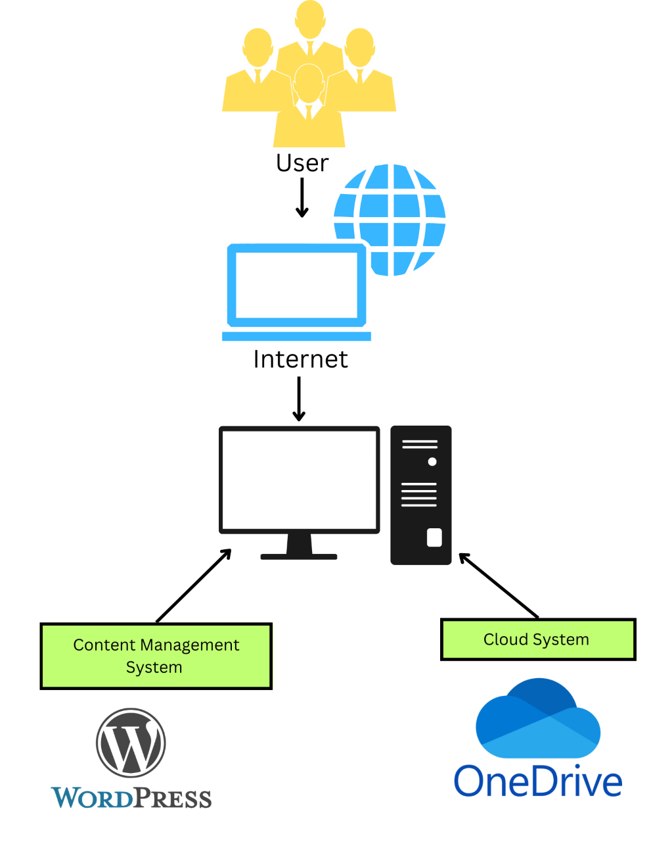

8. Risk Analysis

Risk Analysis

Security is the main consideration in our risk analysis criteria. Our website stores private information, thus if there are any privacy violations, the company could face legal repercussions. We also consider our use cases that involve modifying data to be high risk as well.

Regardless of whether it involves updating or deleting player data. It is critical that any information about a player who departs the squad be deleted properly in order to abide with legal requirements. Updates to information should be made correctly if they are necessary. If any information is missing or incorrect, it could have negative effects such as causing a player to get hurt. Due to these risks being primarily human errors . We plan on to lessen these risks by bringing in a student intern to serve as a data analyst. The student intern will work closely with the Universities’ IT help desk to ensure that all data is accurate. Along with a student intern, WordPress will provide technical support, should any issues come up.

**High Risk Cases**

* Deleting Player Data
* Update Strength Statistics
* Nutrionist Has New Player Diet Recommendation
* Admin needs to delete previous physical data
* Admin Adds Current Oppenents Team Information To Database

**Low Risk Cases**

* Speak to a help desk representative
* Edit Website information
* Player needs to speak to a help desk representative

9. Team Charter

Team Charter

Our team wishes to lay out all the requirements needed to create a efficient, secure, and optimized way for the University of Louisville basketball team to collect, upload, view, and analyze data from every part of their team’s operations. Their goals are very important to us as we all have enjoyed watching UofL basketball and wish to help them achieve as much as we can. Additionally, each one of our team members is very motivated by taking on new and exciting challenges such as this one. Our team is group oriented and communicates with each other on all of the decisions that we need to make for this project. We will achieve the goal of implementing a new system for the UofL basketball team by working together on all of the iterations both in class and out while trying to smoothly transition the as-is model into the to-be model.

Our goal is to create a new and optimized system for the University of Louisville’s basketball team and change the way they use their data. Their current as-is system is sub-optimal and needs to be changed to create a secure, user-friendly and efficient way to use their data. Due to the fact that the as is system is riddled with flaws, our team must create an entirely new system that is entirely different from the old system.

Our team conducts our meetings in person during class and over teams when necessary. We use our class time to create a plan for our individual work, while discussing how we wish to go about our plan of implementing this new system. Meetings are usually conducted by going over all of the assignments that are coming up, and assigning work for each person. When someone feels as though they may need help with a portion of their assigned material they will communicate with the other team members, who will redistribute the work.

The team communicates with each other using Microsoft Teams and over text message, as well as in person. We communicate our ideas with each other to begin, in person, and after discussing our plans, if anyone thinks it would be best to change it later on, we will communicate over text. We communicate with our client and instructor both in person and via email. When one of us has a question we will email them personally, then share the feedback as a team.

When making a decision our team finds that it is best to communicate with each other in person when possible. This allows for each member to have their say and discuss how they feel so that everyone can feel their opinion is heard. When tasked with making a difficult decision our team will go to our sponsor, Dr. Zara Hatami and ask for her input.

Team Ace manages it’s project repository using Microsoft Teams. Every document that we use, have used, or might use is sent to the shared folder on Teams where every team member can access, revise, and edit it as they please.

10. Gantt Chart

[I3 Gantt](https://cardmaillouisville.sharepoint.com/sites/CIS320-TEAMACE/Shared%20Documents/General/I3%20Gantt.xlsx)

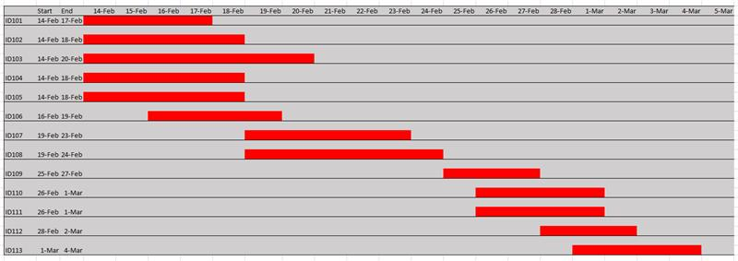

11. Inception Phase Prototype

**Login Page:**

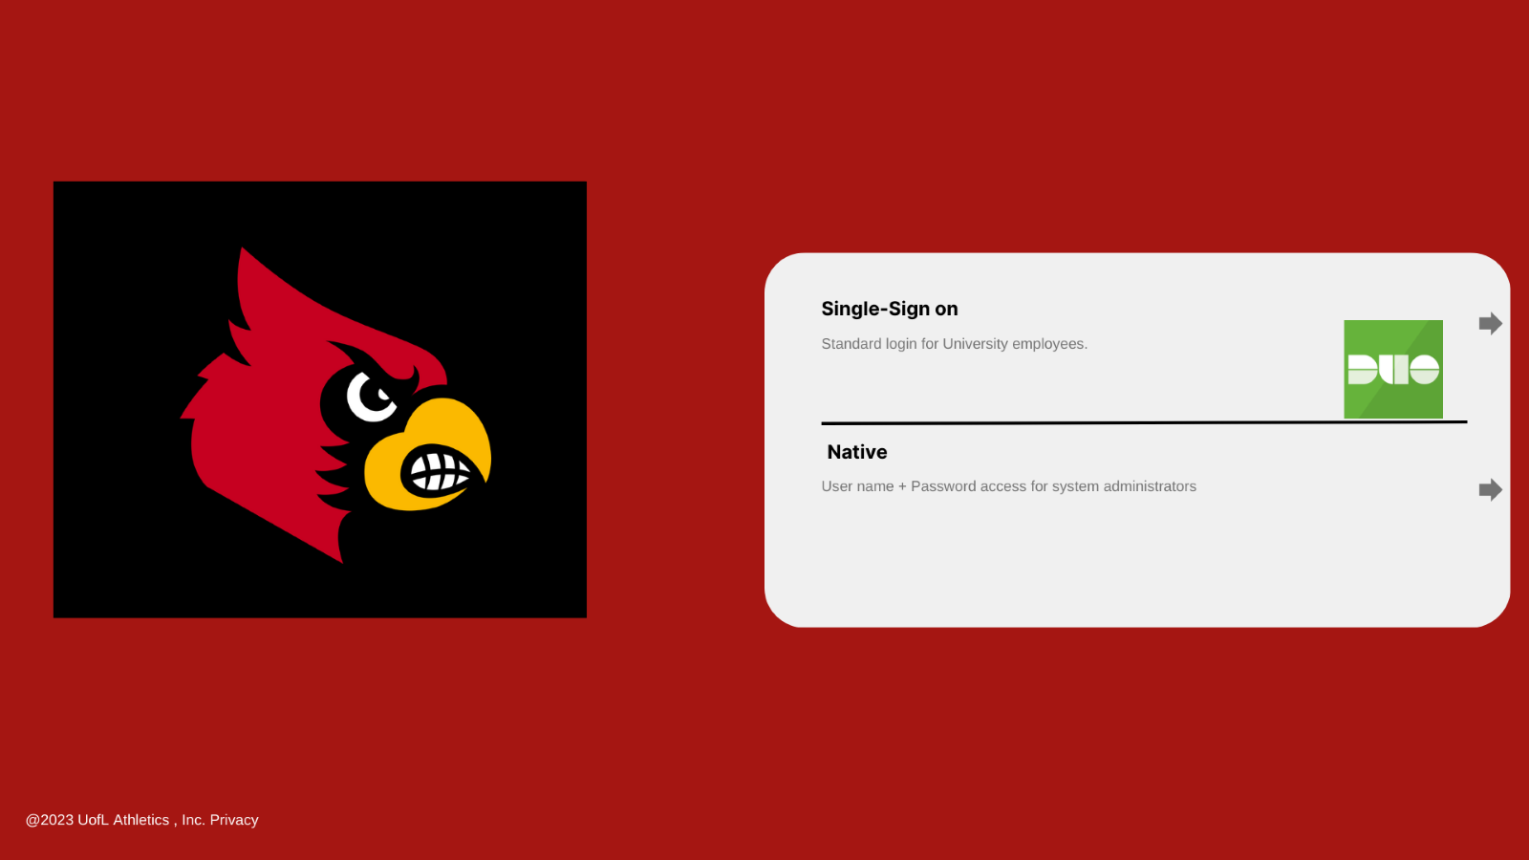

**Home Page:**



**Previous Game Page:**

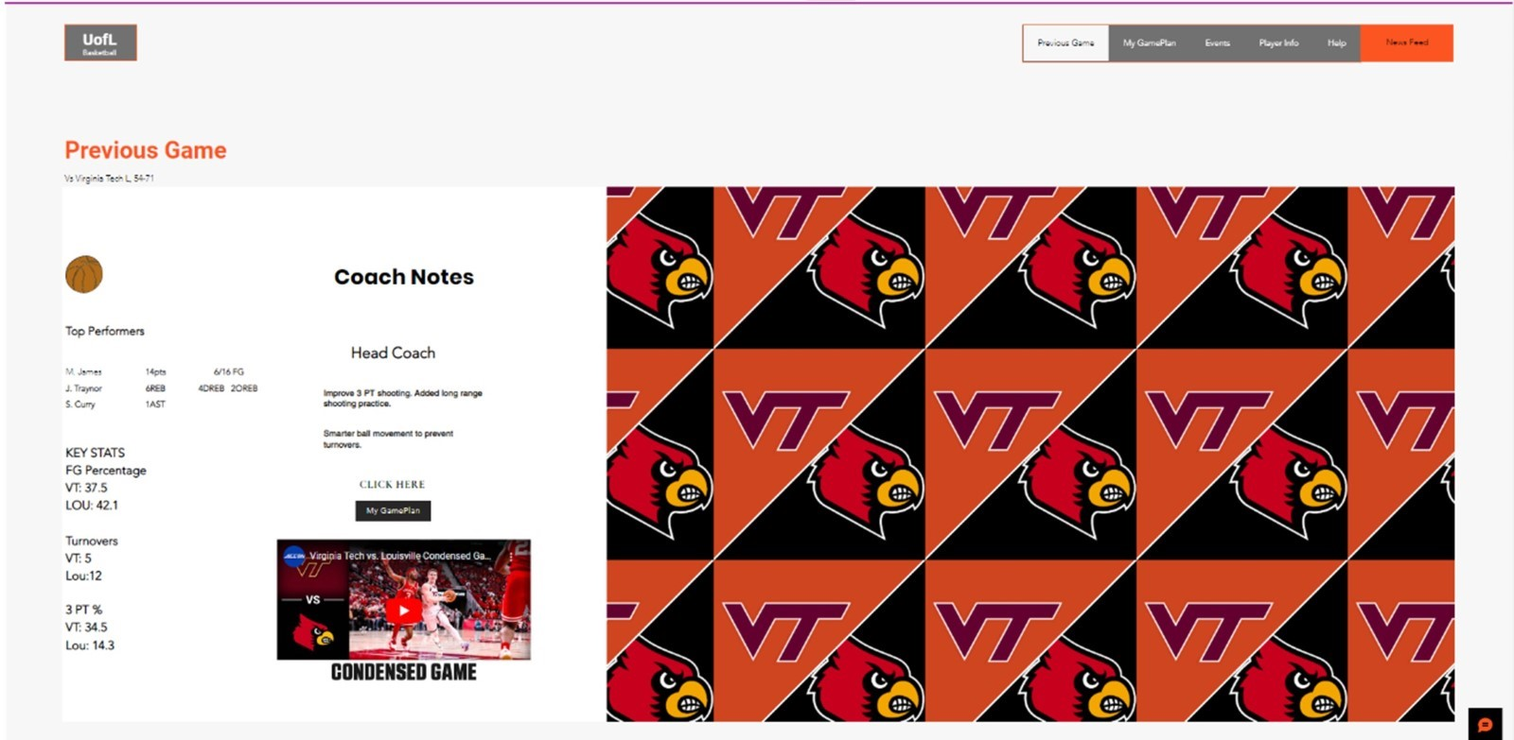

**Current Game Page (GamePlan):**

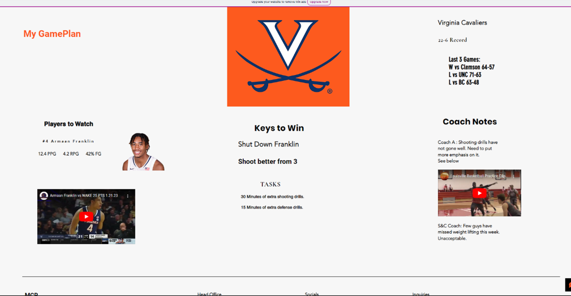

**Event Page:**

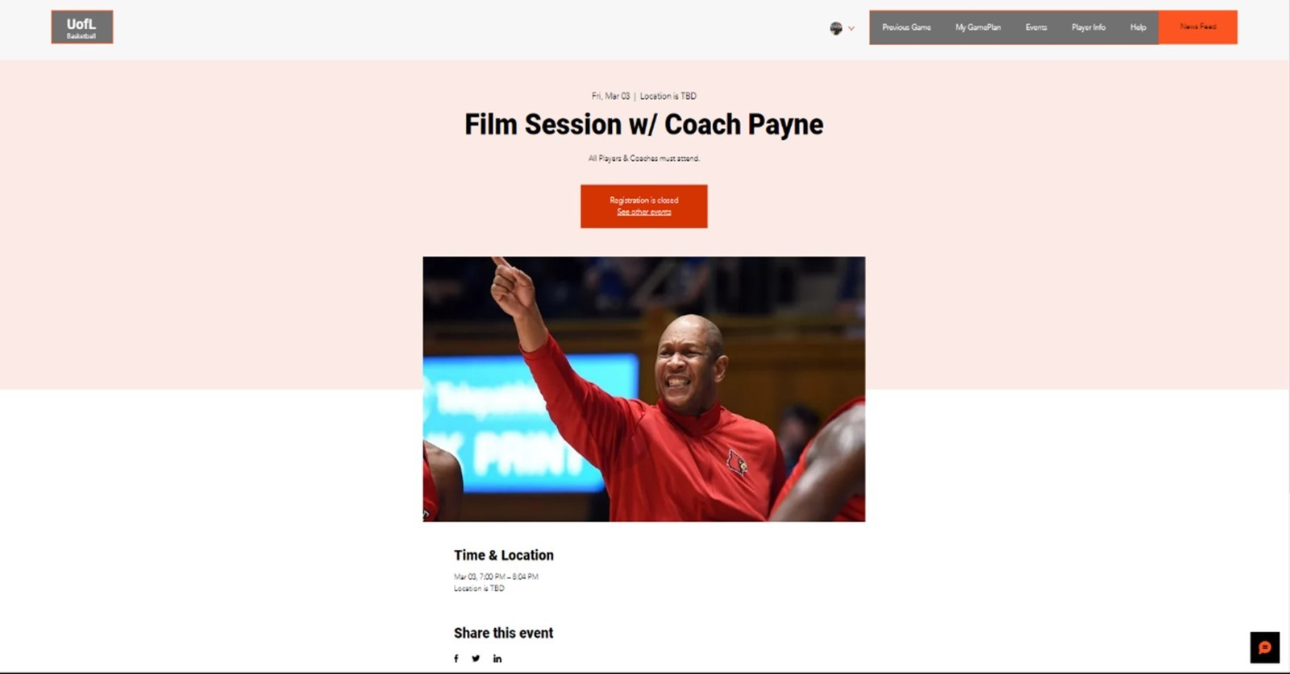

**Player Page:**

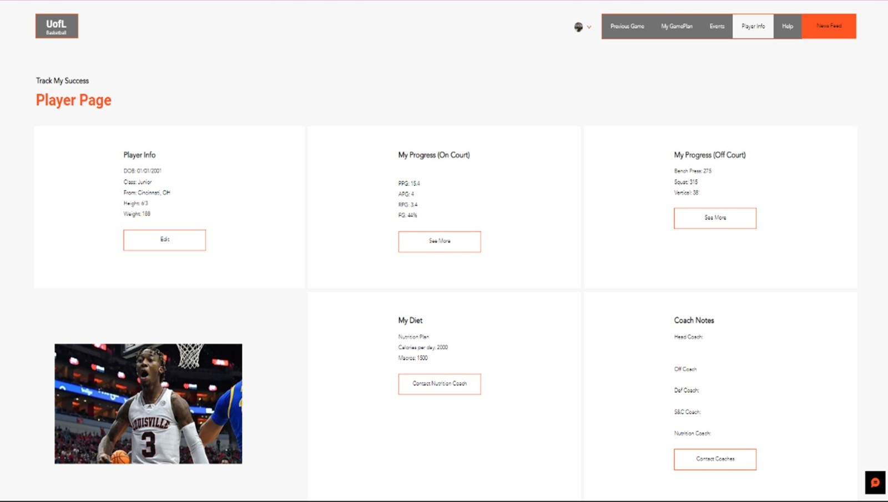

Appendix A: Feasibility Analysis

**Technical Feasibility**

The team will need to convert from their current hard drive and excel sheet system to a cloud-based system in order to handle this problem. As a result, they would be able to store all of their data in a single area that is accessible from any location. This means that coaches and other professionals can use their devices to get the information they need from their office, home, or even while traveling. There are many benefits to using a cloud-based solution to manage data for the UofL Men's Basketball team. A cloud-based system makes it much easier for the many different professionals within the athletic department to access and utilize the data. Rather than having to physically transfer data between different devices, everyone can simply log in to the cloud-based system and access the data they need in real-time. This can lead to more efficient and effective decision-making, as coaches and other professionals can quickly access the information, they need to make informed decisions.

The ideal option for the company's content management system would be WordPress. WordPress is an effective content management system that the University of Louisville Men's Basketball team could utilize to manage and analyze their data. With WordPress, the UofL Men's Basketball team can manage their data in a more efficient and secure way, enabling coaches and other professionals to make more informed decisions and ultimately improve the team's overall performance. WordPress has the ability to be utilized to establish a central repository for all the information gathered by the UofL Men's Basketball team. You can limit who has access to see and update the data using user roles and permissions. In order to aid with data visualization and analysis, WordPress offers many different plugins to create charts and graphs that help analyze the data. Finally, the site can be hosted on a cloud-based platform to make the data easily accessible to everyone within the athletic department.

**Economic Feasibility**

The affordability of WordPress is one of its main benefits. The platform itself is free to use, however there are certain upfront charges associated with putting up a WordPress site (including web hosting and domain registration). WordPress for Business is billed at a $25/month annual fee, which will come out to about $300 a year. Which will be a reasonable price considering it will meet our organization's demands and then some. It also allows for simplicity in terms of adapting your WordPress site to needs, all without spending extra money thanks to the abundance of free and premium plug-ins available.

For an organization such as this one which is in need of a online storage and productivity software, OneDrive is one of the most cost-effective options. You can access business-class email, Office apps, and other services, as well as 1 TB of cloud storage per person, with a Microsoft 365 Business Standard subscription which will cost $12.50/month with an annual subscription ($150/ year). This subscription-based business model is affordable, especially for organizations with lots of users who need access to these tools and services. Additionally, One Drive's cloud storage eliminates the requirement for physical storage devices, saving businesses money on hardware and maintenance expenses. The danger of data breaches and other security concerns can be decreased thanks to OneDrive's advanced security features, which include data encryption and two-factor authentication.

**Organizational Feasibility**

As it currently stands The University of Louisville basketball team lacks the technology needed to have a useful analytics system. I can imagine that the University of Louisville basketball team's existing analytics system is challenging to handle because it lacks the essential technologies. In this digital age with big data the current excel sheet system they are using would not be the most feasible. A new system would need to be developed that would make information easily available, usable, and safe, as well as creating a database that is simple to use for both data producers and users. In addition, the system should be created such that it may be utilized by developers and students in the future, even without the assistance of the original designers. By including these functions, the new system might offer insightful information about player performance, game strategy optimization, and overall enhancing the performance of the team as a whole.

NPV Analysis

[I3 NPV](https://cardmaillouisville.sharepoint.com/sites/CIS320-TEAMACE/Shared%20Documents/General/I3%20NPV.xlsx)

NPV Analysis starts with a base level of Revenue, which was given as $40,900,000 in 2021 and the distribution of revenues which we have been given. NPV will be calculated using the extra revenue provided by this project minus the costs of implementing this system. To calculate the Revenue added by this project we will first estimate the percent increases in revenue by category. We have estimated these as follows: Contributions and Guarantees +2%, Ticket Sales +10%, Media rights +5% Royalties, Sponsorships, Advertising and Licensing +2% and Parking and concessions +8%. We expect all of these increases due to increased interest in the program as this should help to improve the quality of the coaches, player, staff, and organization. We expect these increases in revenues to continue year over year for the life of the system, which we expected to be five years. Overall these increases in categorical revenues add up to an overall increase in revenues of 4.2% per year. Next, we estimate the costs of the system. Each year we will incur a monthly expense of $25 for WordPress, and a $2,000 expense for system support. In the first year we expect a cost of $10,000 for training, and implementation of the system. Next we find the discount rate to use in the NPV calculation. As of March 2023, ten year treasury bills which are widely regarded as a risk free security, have been yielding 4% per annum. Given all of the information above we expect that the net present value of this project is roughly $9.2 million.

